Press Release 05 | 23

Topic | Product News
Headline | Deutsch-DT from ESCHA
Sub-headline | Extreme load - maximum of reliability
Date | July 19, 2023
Character (incl. blancs) | 1.399
Link for add’l information | escha.net

Halver, July 19, 2023 – Extreme load - maximum of reliability
Today's commercial vehicles are flexible, intelligent and fully connected and must withstand harsh operating environments on a daily basis. Shock, vibration, cold and hot temperature ranges, water or mud, these machines have to operate reliably under any condition.
To meet the exceptional high demands in terms of connectivity for Mobile Automation, ESCHA extends its portfolio by further typical rectangular-connectors in Deutsch-DT design.

The ESCHA products do not fall back on field-wireable components – as usual in the market. Instead, ESCHA developed an in-house solution that offers a smart possibility of manufacturing factory-assembled connectors with highest IP protection classes. This avoids long supply chains regarding the components and ensures a high availability.

The new product family is available with different pole counts (2-, 3-, 4-, 6-, 8-, 12-pins) as straight male and female versions. In addition, 2- and 3-pin female variants are also available with LED and protective circuitry.
All connectors in Deutsch-DT design meet the high demands of protection classes IP67, IP68 and IP69. The molded release tab prevents unintentional disconnection under load and increases safety. An also molded dovetail can be used for installation. Optionally, the products are also available with an M12x1 threaded grip body for protective hose mounting.

Photos | Caption
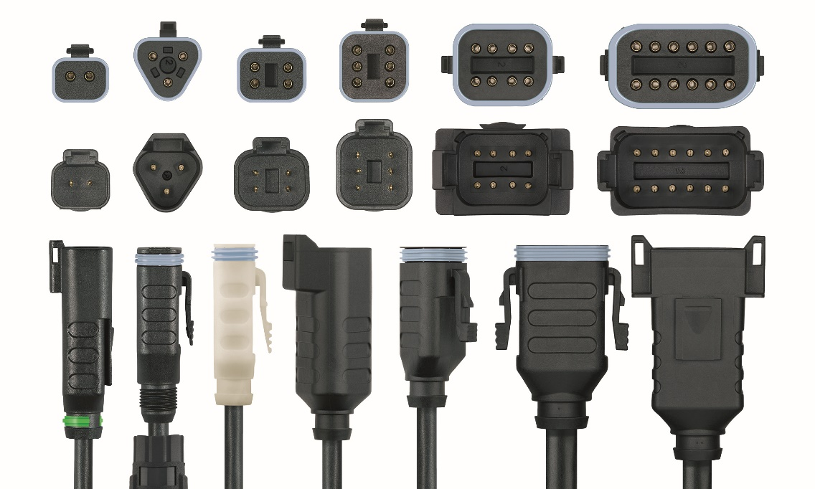
ESCHA PI0523: ESCHA DEUTSCH DT-Family

Source: ESCHA GmbH & Co. KG

About us

The ESCHA Group is a leading supplier in the field of industrial connectivity. For more than 35 years, the family-controlled company has been developing and manufacturing innovative product novelties taking dynamics to the market for automation components. Based on its standard products, the company designs custom-made connectivity and individual special solutions. With about 1000 employees around the globe and highly in-depth development and production, ESCHA is extending its product portfolio constantly and independently. The consolidated group turnover in 2022 amounts to 102 million Euros. ESCHA guarantees high availability and consistent quality of its products worldwide through production facilities in Germany, Czech Republic, Hungary and China as well as licensed production in USA and Mexico.

Reader Contact
ESCHA GmbH & Co. KG
Elberfelder Straße 32 | 58553 Halver | Germany

Phone: +49 2353 708-800
Fax: +49 2353 708-8410
Internet: www.escha.net
Email: info@escha.net

Media Contact
ESCHA GmbH & Co. KG
Dipl.-Design. Dominique Daniela Bicking
Marketing | Communication
Elberfelder Straße 32 | 58553 Halver | Germany

Phone: +49 2353 708-8156
Email: d.bicking@escha.net

